## *Maniac’s wheels on road*

*The problem of accident is a very acute in highway transportation due to complex flow pattern of vehicular traffic, presence of mixed traffic along with pedestrians. Traffic accident leads to loss of life and property. Road accidents cannot be totally prevented but by suitable traffic engineering and management the accident rate can be reduced to a certain extent. For this reason, systematic study of traffic accidents are required to be carried out.49 Proper investigation of the cause of accident will help to propose preventive measures in terms of design and control.*

* ***INTRODUCTION***

*A road traffic accident (RTA) is any injury due to crashes originating from, terminating with or involving a vehicle partially or fully on a public road. It is projected that road traffic injuries will move up to the third position by the year 2020 among leading causes of the global disease burden. Traffic accidents in India are a major source of deaths, injuries and property damage every year. Drowning is a global public health issue, and there is a strong association between alcohol and risk of drowning. Road safety is a multi-sect oral and multi-dimensional subject .it includes orderly development and management of roads, provision of safer vehicles and a comprehensive response to accidents. It relies on modern traffic management system, maintenance of roads and production and maintenance of safer vehicles. Road safety is an issue of national concern, considering its magnitude and gravity and the consequent negative impacts on the economy, public health and the welfare of the people*

## *CAUSES OF ROAD ACCIDENTS*

1. ***Road Users –***

*Excessive speed and rash driving, violation of traffic rules, failure to perceive traffic situation or sign or signal in adequate time, carelessness, fatigue, alcohol, sleep etc.*

1. ***Vehicle****–*

*Defects such as failure of brakes, steering system, tyre burst, lighting system.*

1. ***Road Condition –***

*Skidding road surface, pot holes, ruts.*

1. ***Road design –***

*Defective geometric design like inadequate sight distance, inadequate width of shoulders, improper curve design, improper traffic control devices and improper lighting,*

1. ***Environmental factors –***

*Unfavourable weather conditions like mist, snow, smoke and heavy rainfall which restrict normal visibility and makes driving unsafe.*

1. ***Other causes –***

*Improper location of advertisement boards, gate of level crossing not closed when required etc.*

## *ACCIDENT STATISTICS*

## *KEY FACTS:*

* *Approximately 1.35 million people die each year as a result of road traffic crashes.*
* *The2030 Agenda for Sustainable Development has set an ambitious target of halving the global number of deaths and injuries from road traffic crashes by 2020.*
* *Road traffic crashes cost most countries 3% of their gross domestic product.*
* *More than half of all road traffic deaths are among vulnerable road users: pedestrians, cyclists, and motorcyclists.*
* *93% of the world's fatalities on the roads occur in low- and middle-income countries, even though these countries have approximately 60% of the world's vehicles.*
* *Road traffic injuries are the leading cause of death for children and young adults aged 5-29 years.*

## *EXISTING MEASURES IN AUTOMATIVES*

*According to the*[*World Health Organization*](https://en.wikipedia.org/wiki/World_Health_Organization)*(WHO), 80% of cars sold in the world are not compliant with main safety standards. Only* ***40 countries have adopted the full set of the seven most important regulations for car safety****. Improvements in roadway and motor vehicle designs have steadily reduced injury and death rates in all*[*first world*](https://en.wikipedia.org/wiki/First_world)*countries. Nevertheless, auto collisions are the leading cause of injury-related deaths, an estimated total of* ***1.2 million in 2004, or 25% of the total from all causes****. Of those killed by autos, nearly two-thirds are pedestrians. The rising trend of*[*Autonomous Things*](https://en.wikipedia.org/wiki/Autonomous_Things)*is largely driven by the move towards the*[*Autonomous car*](https://en.wikipedia.org/wiki/Autonomous_car) *that both addresses the main existing safety issues and creates new issues. The autonomous car is expected to be safer than existing vehicles, by eliminating the single most dangerous element - the driver. A*[*subset*](https://en.wikipedia.org/wiki/Subset)*of crash avoidance is driver assistance systems, which help the driver to detect obstacles and to control the vehicle. Driver assistance systems include:*

* *DADS' DADS: Driver Alertness Detection System. System to prevent crashes caused by fatigue*
* [*Automatic Braking*](https://en.wikipedia.org/wiki/Automatic_Braking)*systems to prevent or reduce the severity of collision.*
* [*Infrared night vision*](https://en.wikipedia.org/wiki/Automotive_night_vision)*systems to increase seeing distance beyond headlamp range*
* [*Adaptive headlamps*](https://en.wikipedia.org/wiki/Adaptive_headlamps)*control the direction and range of the headlight beams to light the driver's way through curves and maximize seeing distance without partially blinding other drivers*
* [*Reverse backup sensors*](https://en.wikipedia.org/wiki/Reverse_backup_sensors)*, which alert drivers to difficult-to-see objects in their path when reversing*
* [*Backup camera*](https://en.wikipedia.org/wiki/Backup_camera)
* [*Adaptive cruise control*](https://en.wikipedia.org/wiki/Adaptive_cruise_control)*which maintains a safe distance from the vehicle in front*
* [*Lane departure warning systems*](https://en.wikipedia.org/wiki/Lane_Departure_Warning_System)*to alert the driver of an unintended departure from the intended lane of travel*
* [*Tire pressure monitoring*](https://en.wikipedia.org/wiki/Direct_tpms)*systems or*[*Deflation Detection Systems*](https://en.wikipedia.org/wiki/Deflation_Detection_System)
* [*Traction control systems*](https://en.wikipedia.org/wiki/Traction_control_system)*which restore traction if driven wheels begin to spin*
* [*Electronic Stability Control*](https://en.wikipedia.org/wiki/Electronic_Stability_Control)*, which intervenes to avert an impending loss of control*
* [*Anti-lock braking systems*](https://en.wikipedia.org/wiki/Anti-lock_braking_system)
* [*Electronic brake force distribution*](https://en.wikipedia.org/wiki/Electronic_brakeforce_distribution)*systems*
* [*Emergency brake assist*](https://en.wikipedia.org/wiki/Emergency_brake_assist)*systems*
* [*Cornering Brake Control*](https://en.wikipedia.org/wiki/Cornering_Brake_Control)*systems*
* [*Assured Clear Distance Ahead*](https://en.wikipedia.org/wiki/Assured_Clear_Distance_Ahead)*measurement and speed governance systems*
* [*Pre-crash system*](https://en.wikipedia.org/wiki/Precrash_system)
* [*Automated parking*](https://en.wikipedia.org/wiki/Automatic_parking)*system*

## *PASSENGERS’ SAFETY*

[*Crashworthy*](https://en.wikipedia.org/wiki/Crashworthiness)*systems and devices prevent or reduce the severity of injuries when a crash is imminent or actually happening. Much research is carried out using anthropomorphic*[*crash test dummies*](https://en.wikipedia.org/wiki/Crash_test_dummy)*.*

* [*Seatbelts*](https://en.wikipedia.org/wiki/Seatbelt)*limit the forward motion of an occupant, stretch to absorb energy, to lengthen the time of the occupant's negative acceleration in a crash, reducing the loading on the occupants' body. They prevent occupants being ejected from the vehicle and ensure that they are in the correct position for the operation of the airbags.*
* [*Airbags*](https://en.wikipedia.org/wiki/Airbag)*inflate to cushion the impact of a vehicle occupant with various parts of the vehicle's interior. The most important being the prevention of direct impact of the driver's head with the steering wheel and door pillar.*
* [*Laminated windshields*](https://en.wikipedia.org/wiki/Laminated_glass)*remain in one piece when impacted, preventing penetration of unbelted occupants' heads and maintaining a minimal but adequate transparency for control of the car immediately following a collision. It is also a bonded structural part of the safety cell.*[*Tempered glass*](https://en.wikipedia.org/wiki/Toughened_glass)*side and rear windows break into granules with minimally sharp edges, rather than splintering into jagged fragments as ordinary glass does.*
* [*Crumple zones*](https://en.wikipedia.org/wiki/Crumple_zone)*absorb and dissipate the force of a collision, displacing and diverting it away from the passenger compartment and reducing the negative acceleration impact force on the vehicle occupants. Vehicles will include a front, rear and maybe side crumple zones (like Volvo SIPS) too.*

## *UNUSED CAR SAFETY*

*Many different inventions and ideas which may or may not have been practical about auto safety have been put forward but never made it to a production car. Such items include the driver seat in the middle (to give the person a better view) (the exception being the*[McLaren F1](https://en.wikipedia.org/wiki/Mclaren_F1)*super car), rear-facing seats (except for infant car seats), and control stick steering.*

## *ADVANTAGE OF CRASHWORTHY IN INDIAN CARS*

1. ***Advantages of Airbags:***

* *Air bags have been modified and created for injury reduction.*
* *Insurance offers low cost insurances for air bags protection.*
* *Air bag has been designed safely which offer convenience and full comfort to a passenger.*
* *Using the airbag is simple and this process is fast and most compatible one for any problematic issue.*
* *Belt fixing makes air-flying trip little more comfortable and it will safely leave the passenger to the surface*

1. ***Seatbelt***  
   **·** *Seat belt usage reduces the chance of traffic-related fatalities by 45 percent. In 2006 over 15,000 lives were saved by seat belt use.*

* *Wearing a seat belt minimizes the body's contact with the interior of the car resulting in fewer injuries.*
* *Seat belt usage reduces the chance of being injured by up to 50 percent. Seat belts*
* *spread the force of impact over larger parts of the body reducing severity of injuries*
* *Average medical costs for belted drivers are 60 percent less than for unbelted drivers.*

1. ***Laminated glass***

* *Security - Obviously, since laminated glass is harder to break than regular glass, it makes it more secure. This is most likely the reason that most people will choose to have laminated glass installed.*
* *Reduction in Sound - Regular glass allows a lot of sound to penetrate it. This isn’t so with laminated glass, it lets much less sound through, making your home or car a little quieter from hearing all the outside rumbles.*
* *It’s Durable - Can’t really put it any other way, laminated glass lasts longer than regular glass.*
* *It adds Safety - If you have children in your neighbourhood who play outside, the likelihood that you’ll end up with a broken window from a baseball being thrown at it is diminished.*
* *Added Protection from the elements - Because it’s stronger than regular glass, in the event of a hurricane or tornado, it is less likely to shatter and injure those people inside.*

1. ***Crumple zones:***

* *They reduce the speed of the impact.*
* *They redistribute the force of the impact through the car, protecting the occupant.*
* *Crumple designs slow down the speed of a collision, so that the sudden decrease in speed will not impact so forcefully upon the driver. Specifically designed crumple zones located at the front and back of the car slow down the speed of the crash by creating a physical barrier between the car’s mainframe and the object in which the car has collided with. The extra milliseconds it takes to crumple these parts of the car can be enough to slow the crash down.*
* *Upon impact, crumple zones within cars are designed to deform so that all the energy from the crash is transferred into the mainframe of the car, rather than into the car’s occupant. Crumple zones are also designed to limit the deformation of the cabin area of the car where the occupants reside. By strengthening the inside of the cabin, the amount of crumpling in a collision inside the car will be reduced.*

## *DISADVANTAGE OF CRASHWORTHY IN INDIAN CARS*

1. ***Airbags:***

* *Airbags are very effective but it also has some injury risks. Sometimes it could lead to a fatal injury because it is like a belted or unbelted automatic flying vehicle which will fly you without any destination direction.*
* *Accidents Possibilities of air bags passengers becomes high when it leads to any vehicle filled place because vehicle accidents can lead to a major injury.*
* *Resetting your deployed air bags is not possible and you can re-position your airbag once it is deployed.*

1. ***Seatbelts***

* *Seatbelt use tends to increase risk-taking in drivers. This could lead to an increase in more severe accidents, which, in turn, reduces or mitigates the effectiveness of seatbelts.*
* *They sometimes contribute to accident-related injuries, as is described by the term "seat belt syndrome."*
* *In many cases, the fibres of the seat belt can cause harm to the chest and abdominal areas.*
* *It may also cause more serious damage to the internal organs like tearing of the colon or diaphragm. In some cases the lumbar vertebrae may even be fractured or dislocated.*

1. ***Laminated glass***

* *Expensive - laminated auto glass windows are lot more expensive than regular windows. The manufacturing process is more in depth, and the glass requires multiple layers of material, unlike regular glass. Depending on your income, there is a good possibility that if you need replacement windows, you will only be able to replace a couple at a time if you use laminated auto glass.*
* *Less manufacturers - There are much fewer companies who manufacture laminated auto glass than regular glass, so you might have a hard time finding the right company. You might actually have to wait several weeks, or even months before they can be made for you.*

## *Crumple design*

* *The main disadvantage of crumple design in cars is that they greatly increase the cost of repairs after collision. Because the crumple design is so effective, even after a minor impact, the car will often be un-drivable and must be repaired.*
* *Like all other safety features in a car, they must be kept up to date to conform to road safety regulations. This makes the selling of old cars with outdated safety systems extremely difficult.*
* *There are several forces present in the use of crumple zones. They include:*
* *Motion: There is a motion or driving force present when a car is in motion. This driving force propels the car forwards or backwards in any direction. In the case of a collision, the car is likely to be travelling forward. Upon impact, all the car’s motion and kinetic energy is*
* *Inertia: Inertia is tendency of an object to continue in motion after being acted upon by a force. Inertia in a collision acts upon the occupant. In a sudden impact, due to inertia, the passenger will continue to move at the car’s previous speed until it is restrained (i.e. by a seatbelt) or until colliding into another object. Because the crumple design slows down the impact of the collision, the passenger’s inertia will be decreased.*
* ***ABSTRACT***

*As the name suggests this project is about saving life of people. This magniloquent designed car detects various obstacles in the way. There are various obstacles in the way of people driving car such as pits, road barriers. Accidents happen due to this. Our car has various features which save the life of people. There are various causes of accidents on road such as people do not drive safely, there are various obstacles where car gets stuck and people don’t follow traffic rules. Our car has all solutions for this. We researched on this as we found it as a major problem nowadays. There were various problems that we faced such as:-*

*1. We were facing various opposition in making this project.*

*2. We have to design such a car that would solve all the existing problems faced by people.*

*3. We were having difficulty in the sensors part.*

*Our car has various features such as:-*

* 1. ***Pit detection: -***

*Our car can detect various obstacles in the way of people driving such as pits. Car has ultrasonic sensors that will help in pit detection. Ultrasonic sensors will have a range for detection of pits.*

* 1. ***Alcohol detection: -***

*People drink and then drive, due to this he doesn’t have control on car and accidents happen. For solving this problem we have alcoholic put gas sensor at the door which will not let the person enter the car if he is drunk.*

* 1. ***Display of message:-***

*The message will be displayed on the LCD screen that we are using in the car.*

* 1. ***Length determination of pits:-***

*There are three led’s placed in car. Red coloured led will indicate that there is a grave danger for the car. Yellow led will indicate that there is a small pit through which car can pass. Green led will show that the way is clear.*

*As a result of this we found an innovative car that will save life of people with its features that differentiate it from various cars.*

## *THE PROPOSAL*

*Nowadays the main problem driver’s faces in cars are the accidents in daily life. There is no doubt that accidents are often caused by carelessness of people. We have innovated maniac_04 which senses deep pits and road barriers. It detects and informs the driver with a message on the L.C.D display (16cm x 20cm). The model has an ultrasonic sensor attached at front which faces ground and detects the distance; it also has a gas sensor which senses if the driver is drunk or not and automatically locks the door. The driver will not be able to enter the car if he/she is drunk. There are three types of LED - red, yellow and green. Red LED informs the driver that the pit is a grave danger for the car. Yellow led will inform the driver that the pit is small and the car can smoothly rush over. Green LED informs the driver that there is no obstacle or pit. We are also putting proximity sensor that will detect the obstacles in the way of driver. One major problem of accidents is that people don’t give indicators while turning and due to this the other cars are not notified that the car is taking turn or overtaking .Also for solving this problem, we have put automatic indicators that will notify other cars’ drivers that someone is over taking or taking turn which will prevent accidents. We are putting LED which will intimate the car’s driver and the surrounding car by switching on the LED. According to the turn taken by car indicators will switch on.*

*Maniac_04 benefits both the driver and the car-*

* *It causes lesser damage to the car*
* *It is a onetime investment as driver won’t have to pay for the repairing of the car*
* *It causes less damage to the environment.*
* *Maniac_04 is a durable and convenient life saving car.*
* *It will solve all the controversial issues related to accidents.*
* *Maniac_04 is a cheap and affordable product, which can be used by all. The main budget will be around $29-$36.*

## *BRIEF OF SENSORS USED IN OUR PROJECT*

*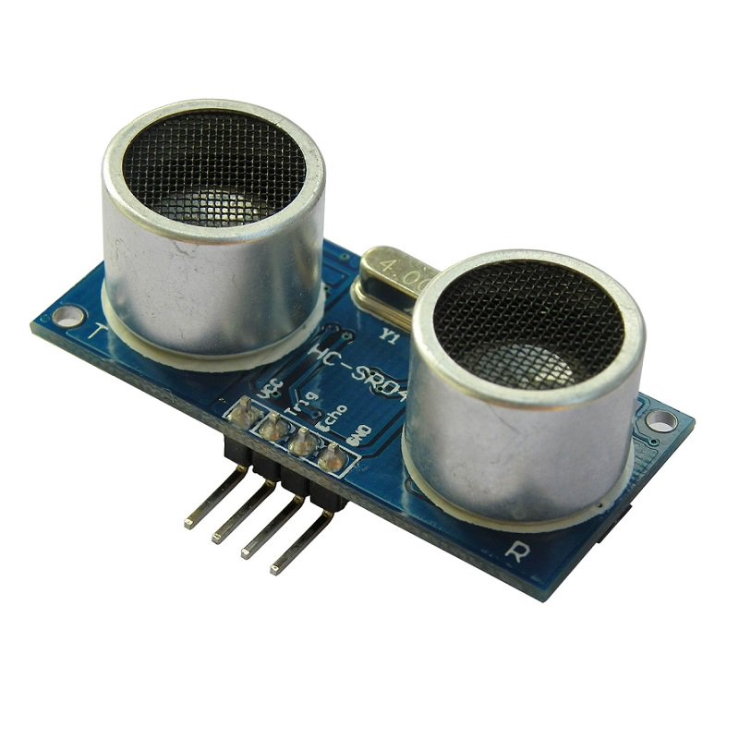Ultrasonic transducers or ultrasonic sensors are a type of acoustic sensor divided into three broad categories: transmitters, receivers and transceivers. Transmitters convert electrical signals into ultrasound, receivers convert ultrasound into electrical signals, and transceivers can both transmit and receive ultrasound. Ultrasonic sensor works on the principle of the ultrasounds. Ultrasounds are the type of sound which cannot be heard easily by a human ear. They have a frequency of 20 KHz and above. Ultrasound can be used for measuring wind speed and direction (anemometer), tank or channel fluid level, and speed through air or water. For measuring speed or direction, a device uses multiple detectors and calculates the speed from the relative distances to particulates in the air or water. To measure tank or channel liquid level, and also sea level (tide gauge), the sensor measures the distance (ranging) to the surface of the fluid. Further applications include: humidifiers, sonar, medical ultrasonography, burglar alarms, non-destructive testing and wireless charging.*

*A gas detector or gas sensor is a device that detects the presence of gases in an area, often as part of a safety system. This type of equipment is used to detect a gas leak or other emissions and can interface with a control system so a process can be automatically shut down. A gas detector can sound an alarm to operators in the area where the leak is occurring, giving them the opportunity to leave. This type of device is important because there are many gases that can be harmful to organic life, such as humans or animals*.

*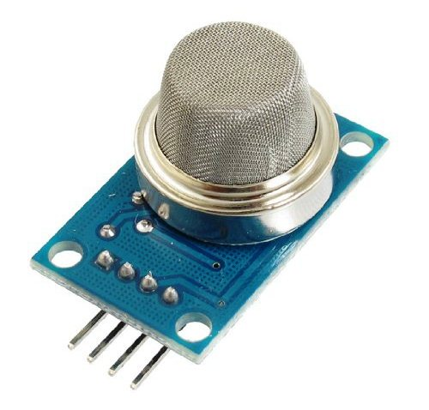Types*:

* *Electrochemical*

### *Catalytic bead (pellistor)*

### *Photo ionization*

### *Infrared point*

### *Infrared point*

### *Photo ionization*

*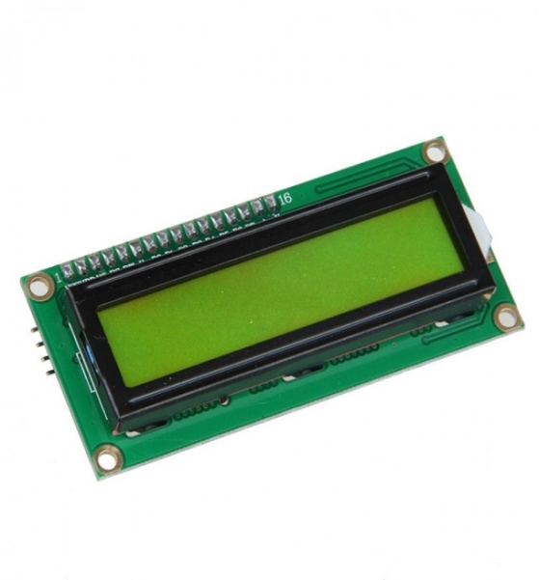A 16x2 LCD display is very basic module and is very commonly used in various devices and circuits. These modules are preferred over seven segments and other multi segment LEDs. A 16x2 LCD means it can display 16 characters per line and there are 2 such lines. In this LCD each character is displayed in 5x7 pixel matrix. It will be used to display the message of the pit’s and obstacle’s distance.*

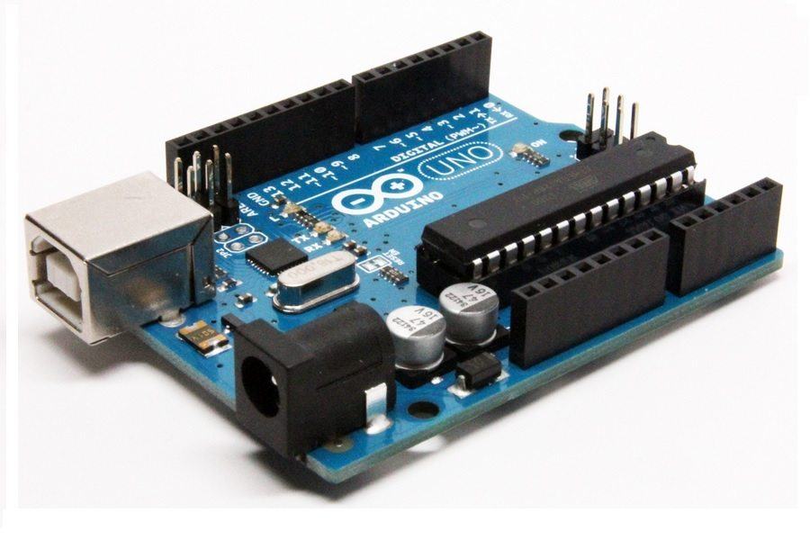

*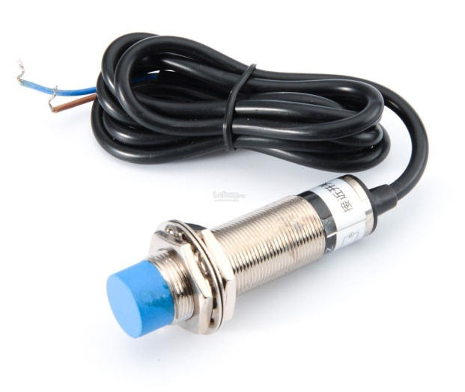Arduino is an open-source hardware and software company, project and user community that designs and manufactures single-board microcontrollers and microcontroller kits for building digital devices and interactive objects that can sense and control both physically and digitally. Its products are licensed under the GNU Lesser General Public License (LGPL) or the GNU General Public License(GPL), permitting the manufacture of Arduino boards and software distribution by anyone. Arduino boards are available commercially in preassembled form or as do-it-yourself (DIY) kits.*

*A proximity sensor is a sensor able to detect the presence of nearby objects without any physical contact. A proximity sensor often emits an electromagnetic field or a beam of electromagnetic radiation (infrared, for instance), and looks for changes in the field or return signal. The object being sensed is often referred to as the proximity sensor's target. Different proximity sensor targets demand different sensors. For example, a capacitive proximity sensor or photoelectric sensor might be suitable for a plastic target; an inductive proximity sensor always requires a metal target. In our project, it will be used to detect pits in the car’s way.*

## *LITERATURE REVIEW*

*The*[*National Crime Records Bureau*](https://en.wikipedia.org/wiki/National_Crime_Records_Bureau)*(NCRB) 2016 report states there were 496,762 roads, railways and railway crossing-related traffic accidents in 2015. Of these, road accidents accounted for 464,674 accidents which caused 148,707 traffic-related deaths in India. The three highest total numbers of fatalities were reported in*[*Uttar Pradesh*](https://en.wikipedia.org/wiki/Uttar_Pradesh)*,*[*Maharashtra*](https://en.wikipedia.org/wiki/Maharashtra)*and*[*Tamil Nadu*](https://en.wikipedia.org/wiki/Tamil_Nadu)*, and together they accounted for about 33% of total Indian traffic fatalities in 2015. Adjusted for 182.45 million vehicles and its 1.31 billion populations, India reported a traffic accident rate of about 0.8 per 1000 vehicles in 2015 compared to 0.9 per 1000 vehicles in 2012, and an 11.35 fatality rate per 100,000 people in 2015. According to Guru raj, the top three highest traffic fatality rates per 100,000 people in 2005 were reported by Tamil Nadu, Goa and Haryana, with a male: female fatality ratio of about5:1.  The reported total fatality, rates per 100,000 people and the regional variation of traffic accidents per 100,000 people varies by source. Dia-wide average fatality rate of 11.6 per 100,000 people and Goa to be the state with the highest fatality rate.*

***1)*** *World Health Organization. Global status report on road safety 2013: Supporting a decade of action. Geneva: World Health Organization; 2013*

***2)*** *Leandro M. Young drivers and speed selection: A model guided by the Theory of Planned Behaviour. Transportation*

***3)*** *Hilton MF, Staddon Z, Sheridan J, Whiteford HA. The impact of mental health symptoms on heavy goods vehicle drivers’ performance. Accident Analysis & Prevention. 2009; 41(3):453–61. Doi: 10.1016/j.aap.2009.01.012*

***4)*** *Ulleberg P, Rundmo T. Personality, attitudes and risk perception as predictors of risky driving behaviour among young drivers. Safety Science. 2003*

***5)*** *Yang J, Du F, Qu W, Gong Z, Sun X. Effects of personal-ity on risky driving behaviour and accident involvement for Chinese drivers.*

## *VARIOUS KEYWORDS USED*

***1****. Ultrasonic sensor*

***2****. Gas sensor*

***3.*** *Proximity sensor*

***4.*** *LCD display*

***5****. Automatic indicators*

## *BIBLIOGRAPHY:*

* [*https://en.wikipedia.org/wiki/Vehicle_safety_technology*](https://en.wikipedia.org/wiki/Vehicle_safety_technology)
* [*https://www.academia.edu/35841044/Research_Paper_Drivers_Effective_Factors_in_Traffic_Accident_A_Sequential_Explanatory_Mixed_Methods_Research_Protocol*](https://www.academia.edu/35841044/Research_Paper_Drivers_Effective_Factors_in_Traffic_Accident_A_Sequential_Explanatory_Mixed_Methods_Research_Protocol)
* [*https://www.slideshare.net/gavitankush/semiroad-accidents-in-india-nar*](https://www.slideshare.net/gavitankush/semiroad-accidents-in-india-nar)
* [*https://www.projectmanager.com/blog/5-tips-creating-better-project-proposal-outline*](https://www.projectmanager.com/blog/5-tips-creating-better-project-proposal-outline)
* [*http://workations.com/advantages-and-disadvantages-of-air-bags/*](http://workations.com/advantages-and-disadvantages-of-air-bags/)
* [*https://auto.howstuffworks.com/car-driving-safety/safety-regulatory-devices/crumple-zone.htm*](https://auto.howstuffworks.com/car-driving-safety/safety-regulatory-devices/crumple-zone.htm)

## 